Microcomputers in Technical Applications (part 1 – sensors and actuators) – v2.1
by Chris Hendriks ( hendrikschris@yahoo.com )
The small computer that we use (Raspberry Pi - RPi) operates in the Access Point (AP) mode. That means that it functions as a (basic) router combined with its function as regular computer. So, the device consists of a (basic) router and a computer directly connected to each other. For convenience we will use the name ´RPi´ for the computer function and ´router´ for the router function (we will also use the name ´RPi´ for the device itself, but in those cases there won´t be any reason for confusion). With your laptop you can get access to the router by selecting the proper wifi network. The name of the wifi network is included in the micro SD card (and written on the sticker on the card or RPi). We will use names consisting of two capital letters

Your laptop receives an IP address from the router. However, you don´t have to know what the address is, since the IP address of the RPi is always 10.3.141.1 . You don´t need it, but you could access the router with the address 10.3.141.0 .

The complete identity of your RPi is contained in the microSD card (SD stands for Secure Digital; the microSD card is a widely used medium for storing digital data). Also, all programs you write are being stored on the microSD card. So, when you put your card in a different RPi, you have an identical environment.

Therefore, remember the name of your card and always connect your laptop to your own network.

When logging in:
- Take care that your laptop is in the proper network (the network of your SD card
- Leave the RPi a minute to boot
- For logging on to your RPi: the name is ´pi´ and the password is ´pi´.

When logging out:
- Shutdown the RPi with the command: sudo shutdown now
- When the session has ended (after 10 to 20 seconds) you can switch of power.

- Introduction – a new information revolutions
Three major developments will together form a new information revolution:
1. Microcomputers will be present in everything, all devices in home and in industry – these computers generate an enormous amount of data.
2. Every computer, also those in devices, will be connected to the internet (Internet of Things) – this causes data to be available everywhere.
3. Data will be analyzed by Artificial Intelligence (AI) software. This opens the possibility to deal with more data as compared to the use of traditional software; and consequently, new applications are being developed. In technical applications the input for AI systems comes from intelligent sensors and the output is used to feed into intelligent actuators.
Artificial Intelligence/ neural networks/ deep learning

bulk data
major developments
(arrows indicate their impact on the various areas)
computers in
social environment
(phones, cameras, etc.)
computers in
technical env.
(sensors, actuators)
computers in
administrative env.
(databases linked)

computer in everything - small, cheap and with wifi/bluetooth

The focus of the workshop is: computers in the technical (industrial) environment. In this environment large integrated systems can be found since every device (sensor or actuator) is connected to one or more central or distributed computer systems. The flow of information corresponds to the basic architecture of a robot (and a human!): intelligent sensors feed data into an AI system which feeds intelligent actuators. In this workshop we will focus on intelligent sensors and actuators and their communication with a (central) system. The AI part of the system and the interconnection of large numbers of intelligent devices (Internet of Things) will be the subject of the next two workshops.

AI was initially boosted by the (valuable) bulk data produced in the social environment (apps on phone or tablet, increased web surfing, cameras everywhere). Bulk data could only be handled by AI software. The technical/industrial environment followed. Initiatives in the area of linked administrative databases are following in for instance stock markets.
AI will be the major development for the coming decades. But AI can only show its relevance by receiving large amounts of data!

The drawback of this high degree of integrations is the increased risk of misuse of information and spreading of malware. Hence, security becomes a major issue.

- RPi – single-board computer
A controller (for sensor or actuator) in the development phase needs a human interface (terminal/keyboard or notebook) but in the operational phase the controller consists of a few chips communicating with central computers through wifi or Bluetooth and with the sensors/actuators through direct wiring. The RPi is a mix between a controller (focusing on I/O activities) and a general-purpose computer (focusing on human interaction). The explosive growth in the number of computers/controllers like this has resulted in an enormous drop in price ($10 - $50) and an increase in availability of software.

The RPi is a typical representative of the marriage between the controller and the general-purpose computer. It is supplied with an Operating System from the Linux family. We will use ‘geany’ as a text editor for writing programs. Python will be used as a programming language. The advantage of geany is that it is aware of the Python syntax (as long as the extension of the program is .py). Python is a programming language comparable to C++. It has a richer set of I/O features for connection to physical systems. Usually the RPi is connected to a laptop through a Wifi network. For implementing the system software and initial programming a terminal and keyboard are to be connected to the RPi.
In typical applications it has advantages to have the RPi close to the sensor/actuator since usually the cabling between the RPi and the plant is more complex than the hardware for wireless communication. The RPi will need a local power supply – however, local power is needed anyway for the sensors and actuators.

We will have a look at the RPi (RPi) in more detail. Apart from the processor and memory, the General-Purpose Input Output (GPIO) bus is an important component of the RPi. There are two ways of numbering the GPIO pins – by counting on the board (BOARD numbering) or by using their name consisting of the letters ‘GPIO’ and a number (we call this BCM numbering; in a program we leave out the letters GPIO and use only the number). In most exercises we will use BOARD numbering. General freeware (public domain and open source software) uses BCM numbering because of its independency of model and type.
The RPi zero is mounted on the breadboard in such a way that the row of pins with even numbers is connected directly to the breadboard. The row with odd numbers is accessible through the pins soldered on the printed circuit board.
For more information on the connection of the RPi to the 5 Volt power supply see Appendix 3 – connection to 5 V power supply.

Characteristics of the GPIO bus:
- port 3 and 5 have a pull-up resistor; the others have pull-down resistors;
- all ports can be programmed to be input or output ports; Q: which should be the ‘neutral’ state or, in other words, which state is safe when connecting external circuits?
- some groups of pins can also be programmed to be used for specific protocols. In the workshop we will use for instance the I2C (Inter Integrated Circuit) protocol available on pin 3 and 5.

The first diagram shows the Raspberry Pi 3B+. The second diagram shows the Raspberry Pi Zero. The Zero has the same IO ports but is simples in the other connections. The Zero has half the RAM memory size as compared to the 3B+ (Zero: 512 MB, 3B+ : 1GB).
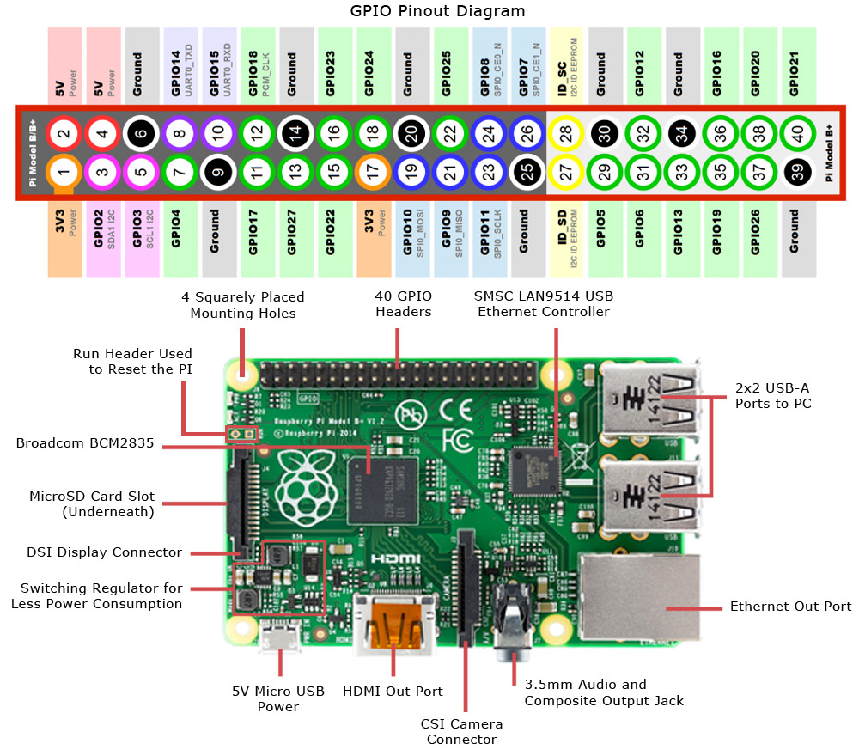
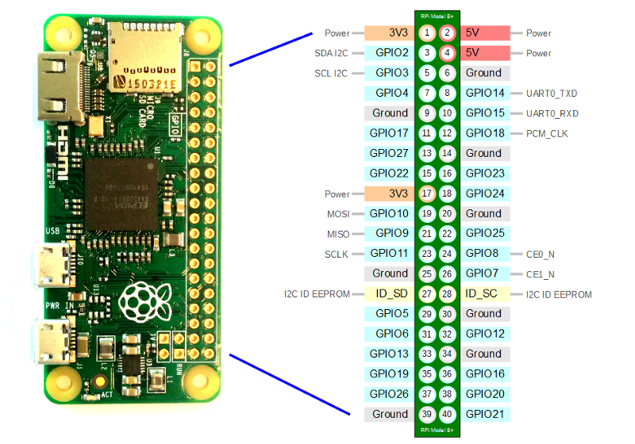

router
Remote Desktop
Connection
(pc or laptop)

monitor/
keyboard
local user
interface.

usb
general
applications +
daemons

shell
hardware
system management software

edi-tor

py-thon
usb
power

If you want to read more about the RPi, you can find the ´Beginners Guide´ in the folder ´Bookshelf´. You can copy the document to your laptop with the scp command: scp pi@10.3.141.1:BeginnersGuide.pdf . (the dot at the end is required; it stands for the current directory on your laptop).
You can use the scp command if both sides have been enabled for it.
- At the RPi side ssh is probably already enabled (check through the ´Preferences´ under the RPi icon (top left corner):
Launch RPi Configuration from the Preferences menu
Navigate to the Interfaces tab
Select Enabled next to SSH
Click OK
- At the laptop side: If you haven't already done so, go to Settings > Apps > Apps & features > Manage optional features > Add a feature, and choose to install OpenSSH Client (the address is (the address is pi@10.3.141.1 and the password is pi).

- Software development
  - Object Oriented Programming
For programming the RPi we use Python. Like most other modern languages Python is based on Object Oriented Programming (OOP). OOP software is based on objects. A possible metaphor to illustrate the concept of an object is the following:
You have an office that you can ask things to be done (e.g. executing administrative operations). You can however only give your orders through a counter. That’s where you hand in your order plus the necessary data and that is where you receive the results. The advantage of an object is its clear interference with the rest of the software. If ‘the office’ does its job well, you can rely on it for 100 %. Usually an object is built up of other objects: a building has a counter where you hand in your orders; inside, other offices with counters are being used to execute specific parts of your order. And so on. We will use this metaphor later on again when we discuss the concept of importing objects.
We can write Python programs using a text editor (as mentioned before ‘geany’ is a suitable one). After writing the program we can run it in the shell. Simply put, the shell is a program that takes commands from the keyboard and gives them to the operating system to perform. One of these commands is ‘python3’ used for executing python programs (the ‘3’ refers to the version of python). Then the command to be entered will be: python3 <name.py>.
We can also start python3 in the REPL (Read-Evaluate-Print-Loop) mode. This means that after the prompt (>>>) a line of code can be entered. The code is executed immediately and any possible output is shown on the screen. We can use this REPL for a quick test or do math and evaluate expressions. To exit the python REPL use the python instruction ‘exit()’. Try the example:
>>> name = "Sarah" (the prompt appears after entering in the shell: python3)
>>> "Hello " + name
'Hello Sarah'
n = 3
m = 16
print(“The sum is“,n+m)

Usually, however, we will write a program, store it and then run it.
For example (in the text window): type the program and then run it after saving.

Basic Python code
Indentation
Python uses indentation to show that code belongs to an earlier statement (nesting). Use the TAB key to get the proper indentation. For example, a for loop in Python is shown in the box.
for i in range(10): # i starts at 0 and is incremented every loop until i=9
print(‘Hello’) # this print loop is executed with i=9 for the last time
print(i)

Also check what happens if you leave out one or both of the indentations.

Variables
To save a value to a variable, assign it like this (see box):
name = ‘Bob’ # the type str (string) is assigned automatically
age = 15 # the type int (integer) is assigned automatically
print (name,’is’,age,’years old’)

Comments
Comments are ignored in the program but are there for you to leave notes. They are denoted by the hash # symbol. Multi-line comments can also use triple quotes like this:
"""
This is how you can also include comments; sometimes it is a convenient way to exclude part of the program.
"""
name = ‘Joe’ # or choose any other name
if len(name) > 3: # ‘len’ is a standard function; returns the length
print(‘Nice name,’,name)
else:
print(‘That is a short name,’,name)

If statements
You can use if statements for control flow (see box):

While statement
The while statement also controls the program flow (like the ‘for’-loop). The following code will print 'hi' ten times (see box):
counter = 10
while (counter>0): # <: smaller than; >: larger than; ==: equal to; !=: not equal to
print(‘hi’)
counter=counter-1

Python Lists
The ‘list’ can be written as a series of comma-separated values (items) between square brackets
Creating a list is as simple as putting different comma-separated values between square brackets.
l = ['physics', 'chemistry', 1997, 2000] # elements can be of different types
l.append(3.5)
print (‘l[0] is:’,l[0],’; and l[4] is:’,l[4])

To access a value in a list, use the square brackets along with the index.
To add an element in a list use the append() method.
When the code in the box is executed, it produces the following result: l[0] is: physics ; and l[4] is: 3.5

Functions
def functionname( parameters ):
.
statements
.
return [expression]

The syntax of a function is shown in the box.
Note the indentation and the colon!

Once the basic structure of a function is finalized, you can execute it by calling it from the program (object) it is defined in or directly from the Python prompt. Following is the example to call the function printme():
def printme(str): # This prints a string passed into this function as a parameter
print(str)
return;
printme("I am a call to user defined function!") # Now you call printme

You can return a value from a function as follows:
def sum(arg1, arg2): # Add both the parameters and return them.
total = arg1 + arg2
print ("Inside the function : ", total)
return total
result_addition = sum( 10, 20 );
print ("Outside the function : ", result_addition)

When the above code is executed, it produces the following result:
Inside the function : 30
Outside the function : 30

Objects and classes; modules, packages and libraries; import.
Objects are an encapsulation of variables and/or functions into a single entity (the office with the counter in our earlier metaphor).
A Class is like an object constructor, or a "blueprint" for creating objects.
Modules, packages and libraries are a way to group objects.
Modules in Python are simply Python files with a .py extension. The name of the module will be the name of the file. A Python module can have a set of functions, classes or variables defined and implemented. Any program (script) is a module.
Packages are namespaces (= common collection of names that are used) which can contain multiple modules (and/or other packages). They can be considered as directories.
The term library does not have any specific contextual meaning in Python. When used in Python, a library is used loosely to describe a collection of the core modules. Sometimes it is used as synonym for package.
We can use a module we created earlier by using the ‘import’ statement. For instance: import time
While importing a module we can give it a different name. For instance: import time as t. We can refer to a particular function from an imported module of a package by using the dot-operator:
import time as t # imports the module ‘time’ under the name ‘t’
t.sleep(5) # makes the program sleep for 5 seconds; ‘sleep’ is an object within the object ‘time’

Alternatively, we can import ‘sleep’ as a separate module.
from time import sleep as s # imports the module ‘sleep’ from ‘time’ under the name ‘s’
s(5) # makes the program sleep for 5 seconds

We can also import all functions of a module with ‘from time import *’; in that case we can refer to a function by only the name it has in the module.
from time import * # imports all modules from time
sleep(5) # makes the program sleep for 5 seconds

Exception handling
Assuming we want to ask the user to enter an integer number. If we use input(), the input will be a string, which we have to cast into an integer. If the input has not been a valid integer, we will generate (raise) a ValueError. We show this in the following interactive session (start the interactive session with the command ‘python3’ and terminate it with the command exit()):
>>> n = int(input("Please enter a number: "))
Please enter a number: 23.5
Traceback (most recent call last):
File "<stdin>", line 1, in <module>
ValueError: invalid literal for int() with base 10: '23.5'

With the aid of exception handling, we can write robust code.
while True:
try:
n = input("Please enter an integer: ")
n = int(n)
break
except ValueError:
print("No valid integer! Please try again ...")
print ("Great, you successfully entered an integer!")

For instance, for reading an integer with input (see box).
Have a look at the program code:
It's a loop, which breaks only, if a valid integer has been entered.
The example script works like this:
The while loop is entered. The code within the try clause will be executed statement by statement. If no exception occurs during the execution, the execution will reach the break statement and the while loop will be left. If an exception occurs, i.e. an incorrect value was entered for n, the rest of the try block will be skipped and the except clause will be executed. The raised error, in our case a ValueError, has to match one of the names after except (in our example only one, i.e. "ValueError:"). After having printed the text of the print statement in the except-block, the execution does another loop. It starts with a new input(). The loop continues indefinitely until the break is executed.
Consider the following code (the variable __name__ gets the value '__main__' if the module is executed as a program (what is the advantage of defining the function p outside the main program?):
def p(): # the function p is defined
i=1
while True:
print(i)
i=i+1
if __name__ == '__main__': # if the object was started as a program the code is executed
try:
p() # call the function p
except KeyboardInterrupt: # pressing Cntrl-C causes a keyboard interrupt
pass # with a keyboard interrupt the loop is left
finally: # the code in the finally clause is always executed
print(“end”)

  - Terminating a session
Since the operating system is Linux-like we can enter most Linux commands as shell commands (the ‘shell’ is also referred to as the ‘terminal’ and working in the shell as working in the terminal mode). For instance, before switching off we give the command: sudo shutdown now (‘sudo’ stands for ‘superuser do’).

- On/off outputs and inputs
Some ports of the GPIO bus (General-Purpose Input Output bus) are Ground (0 V) or 5 V or 3.3 V but most ports of them can be input or output. The program determines whether a port is input or output. In both cases a logical 0 is equal to approximately 0 V and a logical 1 is equal to approximately 3.3 V. Some ports have an internal pull-up resistor (e.g. port 5), others have an internal pull-down (e.g. port 40).

  - Switching a LED on and off using the RPi
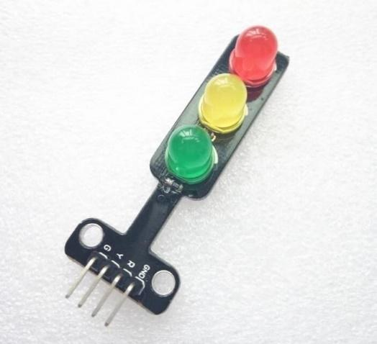
This experiment demonstrates how to attach a LED to the GPIO connector on your RPi and to make it blink with a simple Python program.
In order to switch a LED on and off programmatically we need to connect it between a general-purpose input/output pin (GPIO pin) and the ground. A resistor is necessary to limit the current but this resistor is already included in the traffic light (between each of the LEDs and the R, Y and G pins there is a resistor; be aware: usually there is no resistor and you have to add it yourself). In the case of the traffic light the three LED’s have a common ground.
Build the following circuit:
- take one of the colours of the traffic light (for instance the R-pin) and connect it to a GPIO pin; you can choose any GPIO input/output pin – let's take pin 40;
- connect the common ground-pin of the traffic light (GND) to a ground output of the GPIO connector.

Now we need to make the GPIO pin an output and change the state of the pin between 1 and 0 to switch the LED on and off. Use the code in the text window (you may leave out the comments) to test the circuit.
Run your program. We just told the RPi to supply a voltage of 3.3 V to our circuit using GPIO pin 40. Change the program by making pin 40 False (= 0 Volt) and run the program again.
A warning was given since the GPIO port was still in use. This can be avoided by adding GPIO.cleanup() at the end of your program. Add this line to your program and switch the light on again.
import RPi.GPIO as GPIO # Import GPIO library
Red = 40 # Use pin 40 to connect to Red LED
GPIO.setmode(GPIO.BOARD) # Use board pin numbering
GPIO.setup(Red,GPIO.OUT) # Setup GPIO Pin 40 to OUT
GPIO.output(Red,True) # Turn on GPIO pin 40

You probably think the light is not being switched on. However, it is switched on but switched off again by the cleanup() instruction. This goes so fast that you can’t see the light switching on. Include therefor a sleep period of, for instance, 5 seconds by including the instruction ‘time.sleep(5)’ before the cleanup. Be aware that this instruction can only be executed after importing the module ‘time’. Hence, include also the line ‘import time’.
import RPi.GPIO as GPIO # Import GPIO library
import time # Import 'time' library
Red = 40 # Use pin 40 for the Red LED
timeOnR = 2 # a variable makes it easier to change
GPIO.setmode(GPIO.BOARD) # Use board pin numbering
GPIO.setup(Red, GPIO.OUT) # Setup GPIO Pin Red to OUT
GPIO.output(Red,True) # Switch on pin Red
time.sleep(timeOnR) # Wait
GPIO.output(Red,False) # Switch off pin Red
GPIO.cleanup()

We used the name ‘GPIO’ for the object we created by importing ‘RPi.GPIO’. You can give the object any name. Give the object another name and run the program again (note: the name you give the object has to be used everywhere in the program where you refer to this object).

  - A complete cycle for the traffic light
The added code is in bold
import RPi.GPIO as GPIO # Import GPIO library
import time # Import 'time' library
Red = 40 # Use pin 40 to connect to the Red LED
Yellow = 38
Green = 36
timeOnR = 2 # using a variable makes it easier to change it later
timeOnY = 3
timeOnG = 4

GPIO.setmode(GPIO.BOARD) # Use board pin numbering
GPIO.setup(Red, GPIO.OUT) # Setup GPIO Pin Red to OUT
GPIO.setup(Yellow, GPIO.OUT)
GPIO.setup(Green, GPIO.OUT)

GPIO.output(Red,True) # Switch on pin Red
time.sleep(timeOnR) # Wait
GPIO.output(Red,False) # Switch off pin Red
GPIO.output(Yellow,True) # Switch the yellow LED on and off
time.sleep(timeOnY)
GPIO.output(Yellow,False)

GPIO.output(Green,True) # Switch the green LED on and off
time.sleep(timeOnG)
GPIO.output(Green,False)

GPIO.cleanup()

Here is a slightly more advanced script that blinks the led on for 2 seconds and then off. Extend your code as shown in the box (the added code is in bold; the comments are optional). Now we want to let the 3 LEDs go on for 2, 3 and 4 seconds respectively. Build the circuit by connecting the Y and G pin to port 38 and 36 respectively. The program could look as shown in the box. Try the program.

Try some other sequence and durations.

import RPi.GPIO as GPIO # Import GPIO library
import time # Import 'time' library
Red = 40 # Use pin 40 to connect to the Red LED
Yellow = 38
Green = 36
timeOnR = 2 # using a variable makes it easier to change it later
timeOnY = 3
timeOnG = 4
GPIO.setmode(GPIO.BOARD) # Use board pin numbering
GPIO.setup(Red, GPIO.OUT) # Setup GPIO Pin Red to OUT
GPIO.setup(Yellow, GPIO.OUT)
GPIO.setup(Green, GPIO.OUT)

def switchLED (colour,timeOn): # switchLED is an arbitrary name
GPIO.output(colour,True) # Switch on pin colour
time.sleep(timeOn) # Wait
GPIO.output(colour,False) # Switch off pin colour
switchLED (Red,timeOnR) # red LED on and off
switchLED (Yellow,timeOnY) # yellow LED on and off
switchLED (Green,timeOnG) # green LED on and off

GPIO.cleanup()

Now we see that three ‘blocks’ of code are nearly the same. Would it not be possible to write it only once (in this case the ‘blocks’ of code are small but usually they are much larger)? Consider the program in the box. The code section after ‘def’ (def is an abbreviation of define) is called a function. Test the code.

How could we make the program code even (slightly) more compact?

If we program a general function defLED we would start setting the port to output and at the end set it back to input. Why is it better to add this last instruction and leave it as input port?

  - Blinking yellow light
When the traffic light is not functioning the yellow light blinks. Make the yellow light blink for 10 times with 2 seconds on and 1 second off. Use the ‘while’ or the ‘for’ statement to create a loop.

  - Use a metal detector as a switch
Use the metal detector to detect a car waiting in front of the traffic light and switch the light to green. Build the following circuit: the metal detector gets its own 5 V power (the red wire is 5V and the black wire is 0V; power is taken from the power rail; this power must share a common Ground with the Pi; why?). Use the output of the metal detector as input to the Pi (you can use any GPIO input/output pin – in the following example we use pin 40 = GPIO21).
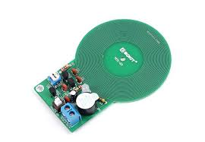
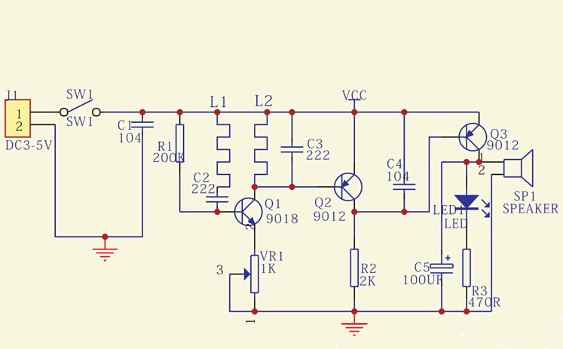

import RPi.GPIO as G
import time as t
d = 40
G.setmode(G.BOARD)
G.setup(d,G.IN)
try:
while (True):
print (G.input(d))
t.sleep(1)
except KeyboardInterrupt:
print ('All done')
G.cleanup()

Use the code in the box to read the input of the metal detector and try the program by moving a metal object over the detector.
Write a program that makes the traffic light remain red until a car arrives. When a car arrives, the light goes to green, then to yellow and then to red again. It should remain red for at least 10 seconds and until another car arrives.

  - Objects and Classes - functions and methods
Like other modern programming languages Python is object oriented. That means that everything in Python is an object. Data are objects, the program itself is an object and functions are objects. All of these objects have types and unique IDs.
In Python an important category of objects is the function. The counter-metaphor of the object was discussed earlier. In this metaphor we compare the function-object with an office with a counter: at the counter you can ask the code of the function to be executed. Calling the function and handing in some parameter values is like going to the counter giving the parameters values and asking the function to be executed. One or more values might be returned. The original parameters are not affected – they are copied for use inside the office.
Objects can ‘contain’ other objects. We can visualize this as a hall in which a number of rooms are built. The hall also has a counter through which everything within the hall can be accessed. The hall can be part of a larger hall, and so on.
It is up to the designer of the software to choose the halls and offices in such a way that the software is testable, re-usable and maintainable.

Going back to our traffic lights. Suppose we have a crossing of two streets (Kingstreet and Queenstreet). That means we have 4 traffic lights (for example Kingstreet-north, Kingstreet-south, Queenstreet-east and Queenstreet-west). For each traffic light we use the functions for a complete cycle, blinking yellow and car detection. How can we write the program in such a way that it remains maintainable (which means it has an orderly structure)? Of course, we could define functions as we did before and have an extra variable referring to the traffic light we are working on. More attractive however is to make a blueprint for a general traffic light and use it to make 4 different objects, one for each traffic light. The blueprint is called a class. The class mechanism makes it easier to make different objects that have, to a large extend, the same structure. The class itself is no object, it only describes the structure of the objects that are made of it afterwards. In that sense it is really a blueprint. The functions defined in a class are called methods. The object made from a class is called an instance of the class.
Classes are not only valuable when a number of objects are needed that are more or less similar, they become essential when a number of objects are needed that run in parallel. We will discuss this situation in more detail in chapter 12 Real-time application.
class TrafficLight:
def __init__(self,red,yellow,green,detector):
self.red=red # the parameters that will be passed on are copied
self.yellow=yellow # to parameters within the object that is made of
self.green=green # the class later; in the metaphor of the room: a copy
self.detector=detector # is made of the parameters instead of the original
# parameters being used
def cycle(self):
GPIO.output(self.red,True) # Switch on pin Red
time.sleep(timeOnR) # Wait
GPIO.output(self.red,False) # Switch off pin Red
:
def blink(self): # the blink method is defined
:
def detect(self): # the method that detects whether a car has arrived
:
# imports and initializations
:
# 4 objects are instantiated, one for each traffic light
north = TrafficLight(NorthRed,NorthYellow,NorthGreen,NorthDetector)
south = TrafficLight(SouthRed,SouthYellow,SouthGreen,SouthDetector)
east = TrafficLight(EastRed,EastYellow,EastGreen,EastDetector)
west = TrafficLight(WestRed,WestYellow,WestGreen,WestDetector)

# remainder of program code in which we, for instance, start a cycle at the lights of
# Kingstreet-north by the statement: north.cycle();
# ´self´ is included to facilitate the process of copying the parameters during initialisation; __init__ is automatically called
# when the new object is created (a new instance is made of the class)

- Relay (if available)
Often you want to control units or systems requiring a higher voltage using the RPi. For example, you want to switch on a lamp, an electromotor or an alarm system. For this purpose, relays can be used between the RPi and the device. The relay “switch” is activated by means of a low-voltage output of the RPi. Apart from the limited voltage of the output port (0 to 3.3 V), also the current it can supply is only small (max per output 18 mA; max all outputs together 50 mA). However, if you have your load switched on by a relay, it´s only the relay that limits the voltage and the current at the load side. Of course, you have to take care that the current required for switching the relay is not more that the current the RPi can supply. Usually, a small amplifier is included to switch the relay.

Connect the red led of the traffic light through the relay to a 5V power supply.
Connect the primary side of the relay to the RPi. An optocoupler and an amplifier are included in the circuit at the primary side. What is the use of each of them?

Build a circuit and write the required program for the RPi to switch the led on for 2 seconds (so, the led is normally off).

- PWM (pulse width modulation)
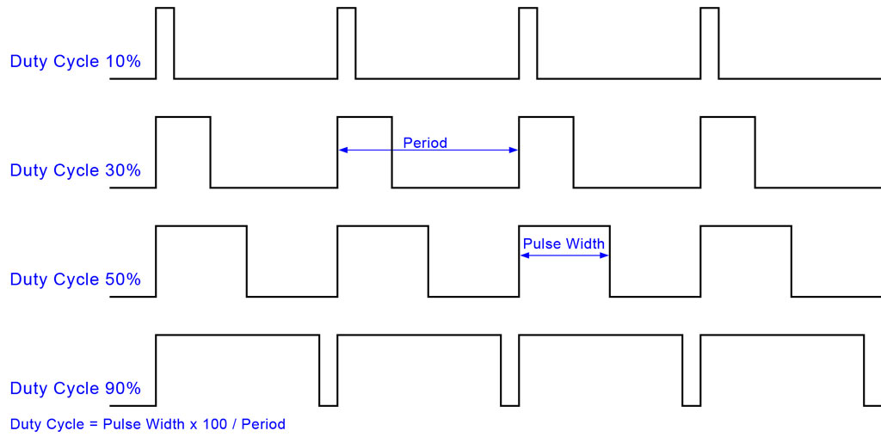
PWM (pulse width modulation) is used in many systems. It means that a periodic signal is high for a certain part of the cycle and low for the rest of it. The percentage of time that the signal is high is called the duty cycle.

An application example: by having a frequency of 50Hz or more and varying the duty cycle the average voltage is varied so we can use PWM to dim a light.

5.1 Changing the duty cycle
In the following examples we use a multi-color LED. The multi-color LED we will be using consists of 3 LEDs, one for each of the primary colors red, green and blue. It can have a common – (ground) or a common + (V).
The R, B and G pins are connected through 330 Ohm resistors to the output pins of the RPi (attention: one type of RGB leds has resistors included; the other one has not – in that case external resistors should be included).
PWM is available through the pigpio library. The pigpio library generates an accurate pwm signal (we could also generate a pwm signal in software but that is less accurate). Pigpio uses BCM numbering.
Since pigpio affects the hardware directly we have to start a specific program at the highest command level. For this purpose, open the terminal and enter the shell command: sudo pigpiod (‘sudo’ stands for ‘superuser do’; pigpiod is the daemon for pigpio). At the end of our program we have to terminate the daemon with the shell command: sudo killall pigpiod.

Let’s make a PWM signal at the output port 21 (BCM numbering; that is 40 in BOARD numbering) of 1 Hz. The output port is connected through a 330 Ohm resistor to the red input of the multicolor led.
We create a PWM instance (object) with the command pwm=pigpio.pi() whereby pwm is an arbitrary name.
The code in the box creates the PWM signal with a duty cycle of 25 %:
don’t forget to enter the command sudo pigpiod in the terminal; this creates a daemon

See what happens if we change the duty cycle to 90 % after 10 sec. using the command pwm_r.set_PWM_dutycycle(pin_r,90) and including another sleep period.
import pigpio
import time

pin_r=21
pwm_r=pigpio.pi() # object is made as instance from class
pwm_r.set_mode(pin_r,pigpio.OUTPUT) # makes the port an output port
pwm_r.set_PWM_frequency(pin_r,1) # frequency is set to 1 Hz
pwm_r.set_PWM_dutycycle(pin_r,25) # duty cycle is set to 25 %
time.sleep(5)
pwm_r.set_mode(pin_r,pigpio.INPUT) # pwm signal is removed by making pin_r input
pwm_r.stop() # object is removed

Try other values for the duty cycle.

Try the following exercises:
- the three leds go on and off after each other;
- the three leds go on and off so that colors are mixed;
- make the red light increase in intensity from off to on, in 10 seconds. You will notice that the brightness we experience is not linear; adjust the minimum and maximum value of the brightness in such a way that it gives a better visual effect.
- make the three leds slowly increase in intensity and after that slowly decrease in intensity (after each other or simultaneously).
- is it possible to increase the intensity of ‘red’ during 5 seconds and at the same time increase the intensity of ‘green’ in 7 seconds?

  - Changing the frequency
Replace the LED with a small speaker (buzzer) and give the output a PWM signal with a frequency of 100 Hz and a duty cycle of 50%. What happens if you change the frequency keeping the duty cycle the same?

  - Mixing colors
Now suppose we want to switch on one light and have it go repeatedly through a cycle of increasing brightness in 2 seconds and decreasing brightness in 2 seconds and, while this is going on, we want to start 1 second later with another light going through the same cycle. With the sequential programming we used so far this is very difficult – certainly if the cycles differ in duration and if there are more than two.
import pigpio
from threading import Thread
import time as t
red= 21
blue=20

def completeCycleRed():
# you can copy here the program from the previous exercise
# later you can change some parameters
def completeCycleBlue():
# you can copy here the program from the previous exercise
# later you can change some parameters

threadRed=Thread(target=completeCycleRed)
threadRed.start()
t.sleep(1)
threadBlue=Thread(target=completeCycleBlue)
threadBlue.start()

We would like to have a feature that allows us to start one process and while this process is running, we start another process independently. This feature is offered by ‘threading’ (discussed in detail in chapter 12 Real-time applications). The example in the box shows how to start a thread. Try the example program with varying values for the various parameters. Extend the code with control of the third color (if you prefer you can do the exercise with the traffic light instead).

- Moving a robot arm

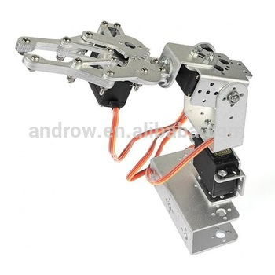
The 3 DOF (degrees of freedom) robot arm uses 3 servo motors.
The position of the servo motor is set by a PWM signal based on a frequency of 50 Hz. With a duty cycle of about 5% the servo angle will be at its minimum (-90 degrees); if the duty cycle is 7.5 % the servo will be at its center position (0 degrees) and if it is about 10 % it will be at its maximum (+90 degrees).
Since the range of the duty cycle in the PWM method in pigpio is from 0 tp 255: 7.5% is about 19, 5% is about 13 and 10% is about 26 (in fact the range is a bit more than 180 degrees and extends from 6 to 32).
Connect the single servo or the bottom servo of the robot to power and the RPi (red: positive of external power supply; black: ground of external power supply and RPi; yellow: PWM input signal). We will use port GPIO21 in BCM numbering (in BOARD numbering pin 40) of the RPi for the PWM signal. A separate power supply is needed because the RPi can’t supply the current drawn by the servo.

Note: if you use two power connections from the same sources, take care of the polarity – since, zero and positive are connected internally. If you are in doubt about the polarity you can check it with a multimeter or simply by connecting a led. If you use power from independent sources you have to connect the zero contacts.

- Enter and run the program in the box (make sure you know the meaning of each of the statements). In the program we use the keyboard keys (in this case ‘a’ and ‘s’ but you can take any other combination) to rotate the servo.
Note: you might notice that the servo has a hysteresis (that means that when it changes direction, it takes an extra step); this hysteresis comes from the internal gearbox.
- Using a single servo, extend the previous program in such a way that all keystrokes are added to a list. Print the list at the end.
start the pigpiod deamon from the terminal
import pigpio
import time
pin = 21
d=19
pwm=pigpio.pi()
pwm.set_mode(pin,pigpio.OUTPUT)
pwm.set_PWM_frequency(pin,50)
pwm.set_PWM_dutycycle(pin,d)
c=' '
while (c!='q'):
if c=='a': d=d-1
if c=='s': d=d+1
if d<12:
d=12
print ("lower limit reached")
if d>28:
d=28
print ("upper limit reached")
pwm.set_PWM_dutycycle(pin,d)
print (“The present position is: “,d)
c=input("enter next move : ")
pwm.set_mode(pin,pigpio.INPUT)
pwm.stop()

A list is a variable like others. It is created by defining a variable and placing the elements in between a pair of square bracket [ ], separated by commas.
L = [] creates an empty list.
L2=[3,5] has 2 elements; L2[0]==3; L2[1]==5
We can add an item to a list using append():
L.append(7) adds 7 to the end of the list.
print(L[3]) prints element 3 of the list.
- Extend the program in such a way that after pressing the ‘q’ key the program asks whether you want to repeat the movement of the servo. If ‘y’ is hit the servo moves to the start position and make the movement stored in the list. Hint: include a small delay between the steps read from the list; otherwise the movement goes too fast.

The following experiment requires a complete robot.
- Connect the three servos. Choose pins to supply the PWM signal. Write a program that allows a user to make the three servos turn in either direction. The movement to any position is controlled by repetitive pressing of keys on the keyboard (choose keys for each of the movements). Obviously in the software three different objects are needed, each with its own unique name. Test the program by making the robot arm pick up an object and place it at a predefined position.
- Extend also this program in such a way that the keystrokes are added to a list and that after pressing the ‘q’ key the program allows you to automatically repeat the movement of the arm (similarly to experiment c. but now with the three servos).

- LCD display with parallel input
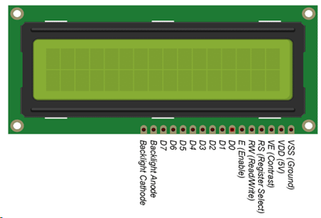
We will import software that uses the LCD display with the following connections to the GPIO pins (BOARD numbering):
1 - Ground; common to the RPi and the separate power supply
2 – VDD (5V); we will use a separate 5V power supply
3 - (contrast) → connected to Ground through a resistor of 1 kOhm (the optimal value depends on the local light conditions)
4 - RS → 40 Register Select; 0: Command, 1: Data
5 - (read/write select) → connected to Ground
6 - E → 38 Enable data transfer
11 - D4 → 37 databit 0
12 - D5 → 35 databit 1
13 - D6 → 33 databit 2
14 - D7 → 31 databit 3
15 (5V) and 16 (0V) are connected to the backlight.

1.After making the connections run 'LCDdisplay.py'. Try to understand the program (appendix LCDdisplay.py)
2. You can use the functions from 'LCDdisplay.py' by importing the code in your program (import LCDdisplay as lcd - ‘lcd’ is an arbitrary name) and calling the functions as for instance lcd.lcd_init()). Write a program that shows some text on the first line and blinks another text on the second line.

- Temperature and humidity sensor
The DHT11 consist of a humidity sensing component, an NTC temperature sensor (thermistor) and an IC on the back side of the sensor. NTC stands for negative temperature coefficient which means that the resistance decreases as the temperature increases.
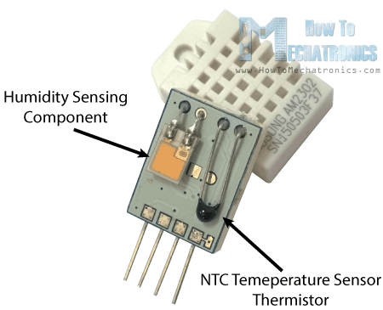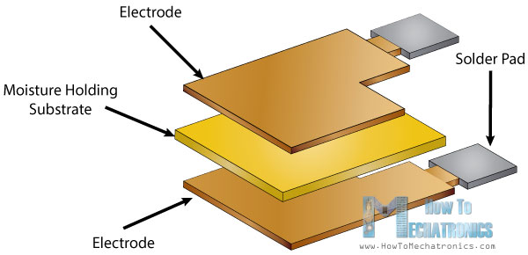

The humidity sensing component has two electrodes with moisture holding substrate between them. So, as the humidity changes, the conductivity of the substrate changes, in other words, the resistance between these electrodes changes. This change in resistance is measured and processed by the IC which makes it ready to be read by the RPi. For measuring temperature these sensors use an NTC temperature sensor also called a thermistor. A thermistor is actually a variable resistor that changes its resistance with change of the temperature. These sensors are made by sintering of semi-conductive materials such as ceramics or polymers in order to provide larger changes in the resistance with just small changes in temperature.

The DHT11 sensors have their own single wire protocol used for transferring the data. This protocol requires precise timing and the timing diagrams for getting the data from the sensors can be found from the datasheets of the sensors. However, we don’t have to worry much about these timing diagrams because we will use the DHT library which takes care of everything.
import Adafruit_DHT
import time

i=0
while (i<10):
humidity, temperature = Adafruit_DHT.read_retry(Adafruit_DHT.DHT11, 21)
if humidity is not None and temperature is not None:
print ('Temperature: ',temperature)
print ("Humidity: ",humidity)
i=i+1
time.sleep(2)
else:
print ("No data received")
i=10

Connect the data output of the DHT11 (pin in middle) to pin 40 of the RPi (pin 40 = GPIO21; the software we will use uses BCM numbering). Connect Vcc (5 V) and ground (ground=pin near led). Test the software in the box.

See what happens when you breathe over the sensor.
Adjust the program in such a way that temperature and humidity are displayed on the LCD display (hint: to convert the variable ‘temp’ into a string use str(temp); to concatenate two strings use “T = “+ str(temp)).
If time allows add the traffic light in such a way that the yellow and red indicate that the humidity gets over 80 % or 90 % respectively.

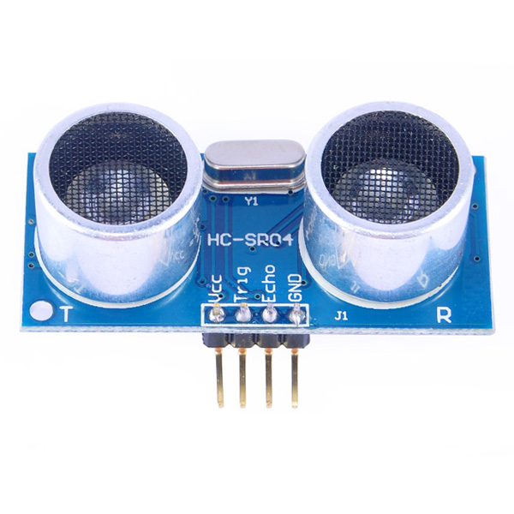
- Distance measurement
import RPi.GPIO as GPIO # import libraries
import time

GPIO.setmode(GPIO.BOARD)
TRIG = 40 # trigger
ECHO = 38 # echo
GPIO.setup(TRIG,GPIO.OUT) # set GPIO direction (IN / OUT)
GPIO.setup(ECHO,GPIO.IN)

print ("Distance Measurement In Progress")
GPIO.output(TRIG, False)
print ("Waiting For Sensor To Settle")
time.sleep(2)
GPIO.output(TRIG, True) # a short pulse is given
time.sleep(0.00001) # to start the measurement
GPIO.output(TRIG, False)
while GPIO.input(ECHO)==0: # start of the echo measured
pulse_start = time.time()
while GPIO.input(ECHO)==1: # end of the echo measured
pulse_end = time.time()
pulse_duration = pulse_end - pulse_start # pulse duration is calculated
distance = pulse_duration * 17150 # distance is calculated
distance = round(distance, 2) # round in 2 decimal places
print ("Distance:",distance,"cm")
GPIO.cleanup()

Use the RPi distance sensor (ultrasonic sensor HC-SR04). It sends an ultrasonic pulse and receives it. The timing of this process is received from and passed on to the RPi. Apart from the 5 V power supply and ground it uses an output from the Pi (trigger) and supplies an input to the Pi (echo). ‘Echo’ is a 5 V output from the sensor so a voltage divider (e.g. 1K and 2K) is to be used (the inputs for the Pi should have a 3.3 V maximum).
The HC-SR04 sensor requires a short 10 μsec pulse to trigger the module, which will cause the sensor to start the ranging program (8 ultrasound bursts at 40 kHz) in order to obtain an echo response. So, to create our trigger pulse, we set the trigger pin high for 10 μsec then set it low again.
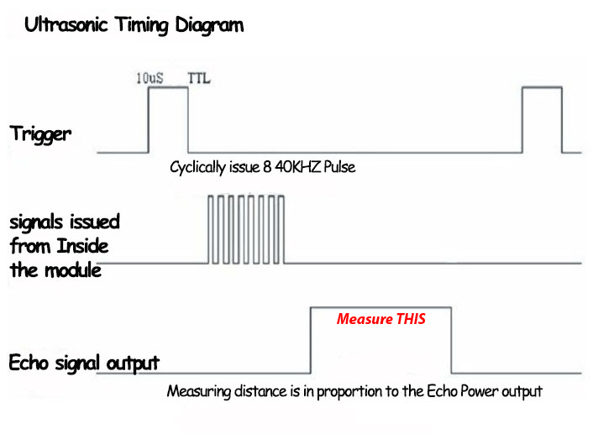
Now that we’ve sent our pulse signal, we need to listen to our input pin, which is connected to ECHO. The sensor sets ECHO to high for the amount of time it takes for the pulse to go and come back, so our code therefore needs to measure the amount of time that the ECHO pin stays high. This is done as follows: in a “while” loop we record the last timestamp for a given condition with the time.time() function. For example, if a pin goes from low to high, and we’re recording the low condition using the time.time() function, the recorded timestamp will be the latest time at which that pin was low.
Our first step must therefore be to record the last low timestamp for ECHO (pulse_start) e.g. just before the echo signal is received and the pin goes high. After that we need the last high timestamp for ECHO (pulse_end).

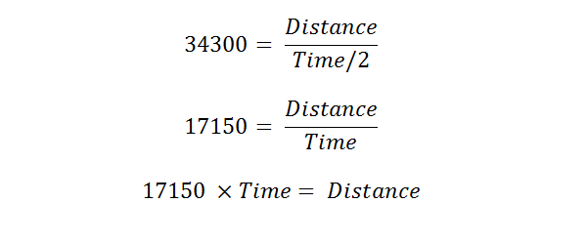
We will take the speed of sound to be 343 m/s (although it is variable, depending on what medium it’s traveling through, in addition to the temperature of that medium).
We also need to divide our time by two because what we’ve calculated above is actually the time it takes for the ultrasonic pulse to travel the distance to the object and back again.

Run the program in the box. Adjust the port numbers if necessary. Take some measurements with a solid object between 5 cm and 50 cm (the actual upper limit is higher). For measuring distances: a sheet of A4 paper is 29.7 cm x 21.0 cm.
What is the accuracy of the measurement device? What is the main source of inaccuracy? How can the measurement be made more accurate?

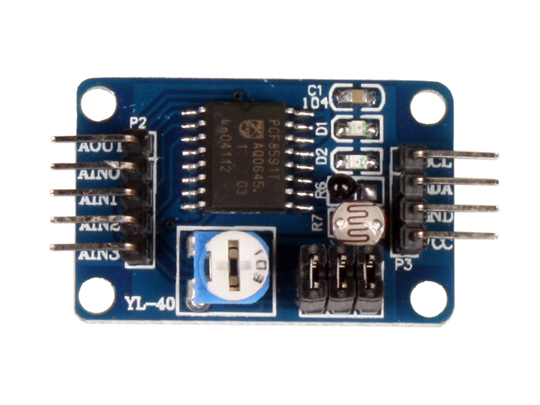
- Connecting the analog world
Most of the surrounding world is analog. So, we need an analog-to-digital convertor to connect a sensor with an analog output to the RPi. Similarly, we need a digital-to-analog convertor to control an actuator with an analog input. Some sensors have the conversion integrated in the device – like the temperature and humidity sensor we used earlier. But in other cases, we have to take care of the AD (analog-digital) and DA (digital-analog) conversion ourselves. The PCF8591 is a popular chip used for this conversion. We will use a printed circuit board (pcb) based on this chip. Apart from the connections to the chip the pcb offers some extra’s (like a led that shows the output voltage of the DA converter).
import smbus #1
import time
import matplotlib.pyplot as plt #a
bus = smbus.SMBus(1) #2
addr = 0x48 #3
A2 = 0x42 #4
cmd = 0x40 #5
current = [] #b
voltage =[]
bus.write_byte_data(addr,cmd,0) #6
time.sleep(0.5)

for i in range (0,200,5): #7
bus.write_byte_data(addr,cmd,i) #8
bus.write_byte(addr,A2) #9
bus.read_byte(addr) #10
v1 = bus.read_byte(addr) #11
v_res =round(v1*3.3/255,2) #12
i_led=v_res/1 #13
v_led=round((i*3.3/255-v_res),2) #14
print('voltage= ',v_led,'current= ',i_led)
time.sleep(0.1)

voltage.append(v_led) #c
current.append(i_led)

plt.plot(voltage,current) #d
plt.xlabel('voltage (V)') #e
plt.ylabel('current (mA)')
plt.show() #f

The PCF8591 uses a 4-wire bus protocol (a ‘bus’ is a communication system that allows the transfer of data between a master and one of the slaves; more slaves can be connected to the bus). The protocol is referred to as I2C (Inter-IC bus). Apart from the common 3.3 V and Ground the bus consists of a serial clock (supplied by the master) and a serial data line.

The hardware connections:
Connect 3.3 V or 5 V and Ground from the RPi to the ADC. Connect the serial data (SDA – pin 2 from above in the picture) and serial clock (SCL – pin 1).
Connect the analog output (AOUT) of the pcb to the + of a LED (take one of the colors of the RGB led without internal resistor). Connect the – of the led to a 1 kOhm resistor and to the input AIN2. The other side of the resistor goes to Ground.

The three jumpers can be used for connecting internal components. We won´t use them.
The supply voltage (in this case 3.3 V) is also the reference voltage.

Enable the I2C bus: click the RPi icon (top left of desktop screen), click ´Preferences´ and select ´Raspberry Pi Configuration´; after a few seconds the configuration screen is shown: select ´interfaces´
and enable I2C.

Software experiment 1 (see the code in the box; the # refers to the line of code):
For experiment 1 we consider only the program code in bold. Here follows an explanation of the software. Import the software library for managing the I2C protocol (smbus – system management bus; #1). Create an object ‘bus’ (#2; the parameter ‘1’ refers to the number of the I2C bus; the name ‘bus’ is arbitrary). The address of the device is specified (#3; the pcb we use has a fixed address, corresponding to the hexadecimal code 0x48) as well as the initialization command (#4) and the address of the input (#5; AIN0=0x40; … ; AIN3=0x43). The address of the device always has to be sent as the first byte after the start condition in the I2C-bus protocol (#6).
The voltage on the output is specified by an integer between 0 and 255 whereby the actual voltage is equal to this integer divided by 255 and multiplied by 5 V. We are going to increase the voltage at the output stepwise between 0 V and 4 V (#7; above 4 V the output voltage is not accurate anymore).
In line #8 the value of the output is sent to the adc.
In line #9 the input AIN2 is selected. The first read operation (#10) starts the ad conversion; the second read operation (#11) does the actual reading. In lines #12 the digital value read from the input is converted into a voltage. In line # 13 the voltage is divided by the resistance, resulting in the current through the resistor and the led (current = voltage/resistance; in our circuit the resistance is 1 kOhm resulting in a current in mA). In line #14 the voltage over the led is calculated.

Run the program in the box and explain the observations.

Software experiment part 2:
It would be nice to have the results of the experiment being plotted in a graph. The library matplotlib.pyplot is imported for plotting this graph (#a). A list is defined for voltage and current (#b). Every new value for voltage and current is added to the lists (#c). The lists are plotted in the plt object (#d), labels are added to the axes (#e) and the plot is shown (#f).
Add the code for plotting the measurements. Explain the resulting graph.
Note: to continue after the plot is shown, the picture of the plot has to be terminated.
Plot the graph of the current against the voltage over the led + resistor (instead of the voltage over led as we did before). Explain the resulting graph. Note: you can plot the results of both experiments in the same graph by calling plt.plot twice and, if you want, call plt.legend([´experiment1´,´experiment2´]) before you call plt.show().

- Motion sensors
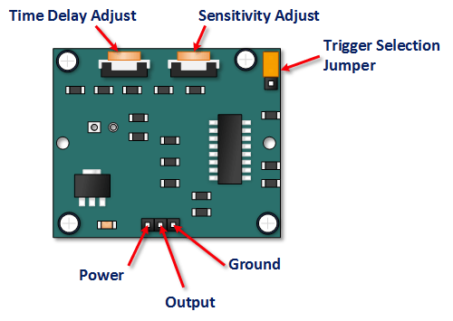
The motion sensor (also called PIR sensor – passive infrared sensor) detects a change in infrared (heat) radiation in relation to position. This change is interpreted as motion. The white cover works as a lens.

Turn ‘Time Delay Adjust’ - the time the output remains high after detecting motion – fully left (min. 2.5 sec.).
Turn ‘Sensitivity Adjust’ fully left (minimal).
The PIR uses a 5 V power supply.
Use a GPIO port without a pull up resistor (e.g. port 40).

Write a program that prints the output of the PIR every second.
Interpret the result (does the PIR measure movement permanently?).
If time allows you can extend the program in such a way that a LED is switched on whenever motion is detected. How can you make the LED being on permanently when there is permanent movement?

- Real-time applications
In real-time environments – as in multi-user environments – it is often necessary to have more than one process/object being executed at the same time. The mechanism of threads makes this possible. Of course, there is only a single processor doing the work but by dividing the time in small time-slots and running each of the threads in a time slot the threads run virtually in parallel. Simplified: with 3 threads every third slot is allocated to a particular thread so it looks as if there are three processors each running at one third of the speed.
Sometimes a thread is waiting for an external event to take place. In that case the thread has to be made inactive. When the event takes place, the inactive state has to be interrupted so that the thread continues processing again.

  - Sharing variables among multiple threads
Sometimes variables have to be shared among multiple threads. To use a variable in more than one thread it must be defined as global.

Run the program in the box.
The program output shows the increase of cycle by 1; every 5 seconds cycle increases by 5 from the thread (as long as it is running). Both threads (main and FiveSecondThread) modify the variable ‘cycle’ and print the value. What happens if the FiveSecondThread continues till cycle is 60?
from threading import Thread
import time
global cycle # cycle is defined as global variable
cycle=0 # cycle gets the initial value 0
def FiveSecond(): # function is defined
global cycle # variable shared with main thread is used
while (cycle<40): # loop: every 5 sec ‘cycle’ is incremented by 5
time.sleep(5)
cycle = cycle + 5
print ("5 Second Thread cycle + 5: ", cycle)
print(“Thread terminates”)

FiveSecondThread = Thread(target=FiveSecond) # create instance of Thread
FiveSecondThread.start() # start thread
while (cycle<50): # main program
cycle = cycle + 1
print ("Main Program increases cycle + 1: ", cycle)
time.sleep(1) # one second delay
print ("Main Program terminates”)

Threads can be created for a variety of functions. Sensors can be read, a request from another station through the network can be handled or other actions can be taken while the main program or other threads run at the same time.

Modify the program in such a way that a LED continues blinking while a new value for the frequency can be entered at any time.
Hint 1: the blinking code runs in a separate thread; the main program communicates with the user; a global variable is used for the frequency;
Hint 2: the function ‘input’ returns a string; to get an integer use: int(input());
Hint 3: be aware that ‘pigpio’ uses BCM numbering (so BOARD numbering port 40 is BCM numbering GPIO21);
Hint 4: if the program terminates in an unexpected way you can terminate the daemon by entering ‘sudo killall pigpiod’ as a shell command (in the terminal); after that you can start the daemon again with the shell command ‘sudo pigpiod’.

  - Interrupt Driven Threads
When we are waiting for an action to take place – for instance a GPIO pin to change state – we can poll the pin permanently using an infinite loop, but that utilizes a lot of CPU power and makes it even impossible to use the computer for other tasks. There is however another way to deal with this kind of situations: interrupts.
GPIO interrupts allow threads to wait for GPIO events. Instead of repeatedly checking a pin, the code waits for a pin to be triggered, essentially using zero CPU power. Interrupts are based on “edge detection”; an edge defining the transition from high to low “falling edge” or low to high “rising edge”. A change in state, or transition between low and high, is known as an “event”.

How do we detect an interrupt? Obviously looping to check for an interrupt would defeat the point of using it, we would be “polling” the interrupt function instead of the GPIO pin. However, computers have in hardware and system software a function implemented that stops a thread from running until the event occurs (no CPU time is wasted since other threads can still run) or starts a “call-back” function as soon as an interrupt occurs (the main program can continue with other things).
The following example illustrates what is happening: suppose you are waiting for a letter: polling is the act of you waiting at home all day, holding open the letter box and peering out waiting for the postman to arrive. An interrupt in this scenario would be a camera that watches the street for the postman. When it spies the postman, it calls your mobile phone (the call-back) to let you know the postman is 10 minutes from your doorstep.
def FiveSecond():
global cycle
import RPi.GPIO as G
import time
G.setmode(G.BOARD)
G.setup(40,G.IN)
print('5 Second Thread started')
time.sleep(0.01) # allows port to settle
G.wait_for_edge(40, G.BOTH)
cycle = cycle + 5
print ("5 Second Thread cycle + 5: ", cycle)
print('Thread terminates')

Modify the example of the previous section in such a way that some event is to take place before the incrementing of ‘cycle’ in the FiveSecondThread is executed once. For generating an event you can make for instance an input high by connecting it with a pull-up resistor to 3.3 V and switching it to 0. The code in the box shows the modification of the thread that waits for the interrupt (hint: make the main program run until a KeyboardInterrupt terminates it – this allows you for more time to generate the interrupt).

Note that: when a KeyboardInterrupt is received the thread that is running at that moment terminates and the other threads continue.
Adjust the program in such a way that the interrupt can be repeated three times. Each time an interrupt is given the counter should be incremented by 5 just once. What do you notice if no precautions are being taken? How can multiple interrupts be avoided?
Since bouncing of switches is a common problem, we can set the parameter ´bouncetime´ in the ´wait_for_edge´ function.

- Communication
The RPi has on-board Wifi and Bluetooth. For the communication example we will use TCP/IP over wifi.
Data exchange in Python is based on sockets. A socket is an endpoint for communication between two machines. The connection between two sockets can be considered as a (bi-directional) pipe: what goes in at one side comes out at the other side. The medium can be the Local Area Network, Wide Area Network or the Internet. Bluetooth programming in Python follows the same socket programming model.
As said before a socket represents an endpoint of a communication channel. A channel is always formed between a client and a server:
Server: A server is a machine that waits for client requests and serves or processes them.
Client: A client on the other hand is the requester of the service.

Sockets are not connected when they are first created, and are useless until a call to either connect (client application) or accept (server application) completes successfully. Once a socket is connected, it can be used to send and receive data until the connection fails due to link error or is terminated by the user software.

The class ‘socket’ is a predefined Python class in the RPi. By importing it we have all the communication methods available (for TCP/IP but also for Bluetooth and other protocols).
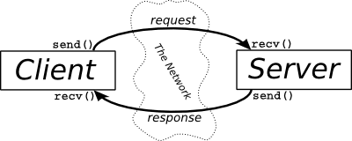
A IP address - in IP version 4 - is represented as a string of 4 octets (together forming the 32-bit address). For example, 10.3.141.101.
The IP address identifies the device e.g. the computer.
However, an IP address alone is not sufficient for running network applications, as a computer can run multiple applications and/or services.
Just as the IP address identifies the computer, the network port identifies the application or service running at the computer.

The following analogy illustrates the meaning of address and port number:
If you have an apartment block the IP address corresponds to the street address. All of the apartments share the same street address. However, each apartment also has an apartment number which corresponds to the port number.

A port number uses 16 bits - so ports can have values from 0 to 65535 decimal.
Port numbers up to 49151 have specific functions. Above that number they can be used by user programs.
In summary: a socket is the combination of IP address plus port number.

The example in the box shows how to establish a connection using a TCP/IP socket, sending some text from the client to the server and the server returning the same text in uppercase (it is just an example to illustrate the bi-directional communication). The client terminates with ’q’ and sends a disconnection code.

Because in our subnetwork we are using only a single device running Python (the RPi), we will do an experiment whereby two processes running at the same RPi communicate. One process is the server and one process is the client.
Since the two processes are running at the same device, they share the same IP address (in our case 10.3.141.1). However, each process will have its own socket for communication.
The server will, by its nature, start making its service available by creating a socket and the client connects to this socket.

In the boxes the two programs for communication – in its most basic form – are being shown
Explanation of the server program:
client
server
import socket
server_addr=("10.3.141.xxx",50000) # the IP address of the server + port number of server should be entered
mysocket=socket.socket()
mysocket.connect(server_addr)
message=input (“message to be sent --→ “)
while message!="q":
mysocket.send(message.encode()) # client sends message
data=mysocket.recv(1024).decode() # client receives data from server
print("received from server: ",data)
message=input("next message to be sent ---> ")
mysocket.close() # disconnect is sent to server; object is terminated
import socket # the class ‘socket’ is imported
server_addr = ("10.3.141.xxx", 50000) # the IP address of the server should be entered + any port of server
mySocket = socket.socket() # the object ‘mySocket’ is created (instance of method socket of class socket)
mySocket.bind(server_addr) # mySocket is linked to the given address
print(“waiting for connection”)
mySocket.listen(1) # wait for connection request; 1 = the number of simultaneous connections
conn, client_addr = mySocket.accept() # conn = new socket object;
print ("Connection from: ", str(client_addr))
while True:
data = conn.recv(1024).decode() # transmitted message is decoded
if not data: # when client sends termination code
break # exit from loop (server closes connection)
print ("from connected user: ", data)
data = data.upper() # message converted to uppercase
print ("sending: ", data)
conn.send(data.encode()) # encoded data are sent
conn.close()

The server starts creating a server socket object that is used to accept incoming connections. The socket must be attached to operating system resources with the bind method; ‘bind’ takes in a tuple specifying the IP address plus a port number to listen on. The IP address is needed since a computer can have more that one IP interface unit. The port number can be any number in the free range. Once the socket is bound, a call to listen puts the socket into listening mode and it is then ready to accept incoming connections. In the line ‘mySocket.listen(1)’ the ‘1’ indicates that only 1 connection is accepted at a time. Once a client makes a connection, a new object is made specifically for that connection and the original object continues waiting for connections (in our case we accept only one connection but in general there can be more than one). The parameter ´conn´ is the name of the connection object and the parameter ´client_addr´ is the address of the client. In an eternal loop the connection object waits for data, prints the data, converts it to upper case and sends it back to the client (this last part is just an example to show that data transfer can take place in both directions). When the client sends a termination code the loop is broken and the program terminates.

Explanation of the client program:
The client instantiates a socket object. This socket is used to establish an outgoing connection to the server using the specified server address (in the workshop set-up: IP address 10.3.141.1 and the port number 50000). In our example a text can be sent to the server while the server responds with the same text in upper case. The connection is being closed by entering a ´q´.

Test the program above by having two processes communicating with each other (which process, the server process or the client process, should be started first?).
Write a client and a server program in such a way that the client asks the server for the position of a switch at the server and switches a LED on or off accordingly.

- The camera
There are two possibilities to connect a camera to the RPi:
- Connect a camera with flat cable to the CSI (Camera Serial Interface) camera connector
- Connect a camera to the USB connector.

CSI connector with picamera

First of all, with the Pi switched off, you’ll need to connect the Camera Module to the RPi’s camera port , then start up the Pi and ensure the software is enabled (sudo raspi-config; Interfacing Options; Camera).
Enter the following code:
from picamera import PiCamera # import the class PiCamera from the picamera library
import time
camera = PiCamera() # an object ‘camera’ is created
camera.start_preview() # the lens is opened
time.sleep(2) # 2 sec are given for adjusting parameters
camera.capture('/home/pi/Desktop/image.jpg') # a picture is taken
camera.stop_preview() # the lens is closed

You can rotate the image by 90, 180, or 270 degrees by including: camera.rotation = 180 (or any other value).
You can view the picture from the (RPi) desktop, i.e. the path given in the capture method.
Now try adding a loop to take five pictures in a row:
for i in range(5):
time.sleep(2)
camera.capture('/home/pi/Desktop/image%s.jpg' %i)
# with the construction %s %i the value of i is converted into a string and included in the text; in that way the pictures
# get successive numbers and in that way unique names

import cv2
cam = cv2.VideoCapture(0)
cv2.namedWindow("test")
img_counter = 0
while True:
ret, frame = cam.read()
cv2.imshow("test", frame)
k = cv2.waitKey(1)
if k%256 == 27: # ESC pressed
print("Escape hit, closing...")
break
elif k%256 == 32:
# SPACE pressed
img_name = "opencv_frame_{}.png".format(img_counter)
cv2.imwrite(img_name, frame)
print("{} written!".format(img_name))
cv2.imshow(img_name,frame)
img_counter += 1
cam.release()
Using the USB webcam camera for video

OpenCV (we use cv2) is very suitable for making and manipulating images. The program in the box shows the video from the webcam on the screen and every time the space-bar is hit an image is stored and shown on the screen.

Note that the quality and configurability of the camera module is highly superior to a standard USB webcam.

Appendix 1 LCDdisplay.py

# The program consists of the following components:
# - imports of the objects we are going to use
# - some definitions to make the program more readable and maintainable
# - defining functions
# * main: the main program; it is composed of an initialization + an endless loop (the loop is left with an exception )
# * lcd_init: initialization
# * lcd_byte: transfer of a byte
# * lcd_toggle_enable: a supporting function used in lcd_byte
# * lcd_string: transfer of a string consisting of a number of bytes
# - the actual program consisting of a call to ‘main’, the code to be executed with an exception and the termination.

import RPi.GPIO as GPIO #import of GPIO module from RPi library
import time # import of time module

# Define GPIO to LCD mapping (based on BOARD numbering)
LCD_RS = 40 # Register Select: low = command, high = data
LCD_E = 38 # Enable (toggling this input means data is being transfered)
LCD_D4 = 37 # the next 4 inputs carry the data
LCD_D5 = 35
LCD_D6 = 33
LCD_D7 = 31

# Define some device constants
LCD_WIDTH = 16 # Maximum characters per line
LCD_CHR = True # Register Select: high = data
LCD_CMD = False # Register Select: low = command
LCD_LINE_1 = 0x80 # LCD RAM address for the 1st line
LCD_LINE_2 = 0xC0 # LCD RAM address for the 2nd line

# Timing constants
E_PULSE = 0.0005 # 2 constants to create a proper toggle signal
E_DELAY = 0.0005

def main(): # Main program block
lcd_init() # Initialize display
while True:
lcd_string("workshop 2019",LCD_LINE_1) # Send some text to be displayed in line 1
lcd_string("RPi",LCD_LINE_2) # Send some text to be displayed in line 2
time.sleep(3) # 3 second delay
lcd_string("in Technical",LCD_LINE_1)
lcd_string("Applications",LCD_LINE_2)
time.sleep(3) # 3 second delay

def lcd_init():
GPIO.setmode(GPIO.BOARD) # Use BOARD GPIO numbers
GPIO.setup(LCD_E, GPIO.OUT) # E is set to output
GPIO.setup(LCD_RS, GPIO.OUT) # RS is set to output
GPIO.setup(LCD_D4, GPIO.OUT) # DB4 is set to output
GPIO.setup(LCD_D5, GPIO.OUT) # DB5 is set to output
GPIO.setup(LCD_D6, GPIO.OUT) # DB6 is set to output
GPIO.setup(LCD_D7, GPIO.OUT) # DB7 is set to output
lcd_byte(0x33,LCD_CMD) # 0011 0011 Initialize
lcd_byte(0x32,LCD_CMD) # 0011 0010 Initialize
lcd_byte(0x06,LCD_CMD) # 0000 0110 Cursor move direction
lcd_byte(0x0C,LCD_CMD) # 0000 1100 Display On,Cursor Off, Blink Off
lcd_byte(0x28,LCD_CMD) # 0010 1000 Data length, number of lines, font size
lcd_byte(0x01,LCD_CMD) # 0000 0001 Clear display
time.sleep(E_DELAY)

def lcd_byte(bits, mode):
GPIO.output(LCD_RS, mode) # selects for command or data
GPIO.output(LCD_D4, False) # make data inputs 0
GPIO.output(LCD_D5, False)
GPIO.output(LCD_D6, False)
GPIO.output(LCD_D7, False)
if bits&0x10==0x10: GPIO.output(LCD_D4, True) #make the data input 1 if corresponding bit is 1
if bits&0x20==0x20: GPIO.output(LCD_D5, True)
if bits&0x40==0x40: GPIO.output(LCD_D6, True)
if bits&0x80==0x80: GPIO.output(LCD_D7, True)

lcd_toggle_enable() # Toggle 'Enable' pin

GPIO.output(LCD_D4, False) # same as above for low bits
GPIO.output(LCD_D5, False)
GPIO.output(LCD_D6, False)
GPIO.output(LCD_D7, False)
if bits&0x01==0x01: GPIO.output(LCD_D4, True)
if bits&0x02==0x02: GPIO.output(LCD_D5, True)
if bits&0x04==0x04: GPIO.output(LCD_D6, True)
if bits&0x08==0x08: GPIO.output(LCD_D7, True)

lcd_toggle_enable() # Toggle 'Enable' pin

def lcd_toggle_enable(): # Toggle enable
time.sleep(E_DELAY)
GPIO.output(LCD_E, True) # E goes up
time.sleep(E_PULSE)
GPIO.output(LCD_E, False) # E goes down
time.sleep(E_DELAY)

def lcd_string(message,line): # Send string to display
message = message.ljust(LCD_WIDTH," ") # text is left justified with spaces added
lcd_byte(line, LCD_CMD) # sends the code for line 1 or line 2 as a command
for i in range(LCD_WIDTH): # sends the characters one by one
lcd_byte(ord(message[i]),LCD_CHR) # ‘ord(message[i]’ is the character at position i

if __name__ == '__main__': # if object started as program the code is executed
try:
main() # call the main function
except KeyboardInterrupt: # pressing a key causes a keyboard interrupt
pass # with a keyboard interrupt the loop is left
finally: # the code in the finally clause is always executed
lcd_byte(0x01, LCD_CMD) # command ‘clear display’ is sent
lcd_string("Goodbye!",LCD_LINE_1) # text is sent
GPIO.cleanup() # all ports used in program are set to input (safer)

Appendix 2 – connection to 5 V power supply.

There are various ways to connect the RPi to the 5 V power supply. Independent of the way the 5 V is connected, the following should be kept in mind:

The RPi itself can supply 5 V through the GPIO port. However, the current that it can supply is limited. Therefor a number of actuators need a separate power supply. Whenever using a separate power supply, one has to keep in mind that the two power sources should share a common Ground.

These are three possibilities to use a separate supply power:
- Power is taken from the desktop or laptop through the USB connector (the current is limited and, in some cases, insufficient); Grounds have to be interconnected.
- Power is taken from two separate adapters; Grounds have to be interconnected.
- Power is taken from a single power supply with two outputs. In that case the Ground is already common and no other connection is needed.

In all cases make sure that you use the proper leads for 5 V (red) and Ground (black, brown or blue). If you are not 100 % sure about the connection check the power supply by connecting a Led (for instance from the traffic light) over it (color to 5 V and common Ground to Ground – if it lights the connections are correct).

Appendix 3 – make a new or a backup SD card

The SD Card Copier application, which can be found on the Accessories menu of the Raspberry Pi Desktop, will copy Raspberry Pi OS from one card to another. To use it, you will need a USB SD card writer.

To back up your existing Raspberry Pi OS installation, put a blank SD card in your USB card writer and plug it into your Pi, and then launch SD Card Copier. In the ‘Copy From Device’ box, select the internal SD Card. This could have a number of different names, and may have something like (/dev/mmcblk0) in its entry, but will usually be the first item in the list. Then select the USB card writer in the ‘Copy To Device’ box (where it will probably be the only device listed). Press ‘Start’. The copy, depending on the size of the SD card, can take ten or fifteen minutes, and when complete you should have a clone of your current installation on the new SD card. You can test it by putting the newly-copied card into the Pi’s SD card slot and booting it; it should boot and look exactly the same as your original installation, with all your data and applications intact.
You can run directly from the backup, but if you want to recover your original card from your backup, simply reverse the process – boot your Pi from the backup card, put the card to which you want to restore into the SD card writer, and repeat the process above.

The program does not restrict you to only copying to a card the same size as the source; you can copy to a larger card if you are running out of space on your existing one, or even to a smaller card (as long as it has enough space to store all your files – the program will warn you if there isn’t enough space). It has been designed to work with Raspberry Pi OS; it may work with other OSes or custom card formats, but this is not guaranteed.

Note, everything on the destination card will be overwritten, so ensure you do not have any critical data on it before starting the copy.

If the intention was to make a new SD card that can be used on any RPi in the Access Point mode, you have to adjust the name of the IP network it advertises. Every card – and hence every IP network – should have a unique name. So far, we used names consisting of two uppercase letters but any naming convention can be used. The name of the SD card is written on the card.

Change the IP network that the RPi advertises by editing /etc/hostapd/hostapd.conf (sudo nano /etc/hostapd/hostapd.conf)
Modify the ssid to the name of SD card; ssid stands for Service Set Identifier and is the name of the IP network.
If the copy has been made from another card that was used as an Access Point the password (raspberry) and the country code (country code is ZM for Zambia and KE for Kenia) can remain as they are.

The new netwok becomes active after reboot (sudo reboot).
Appendix 4 Color code resistors

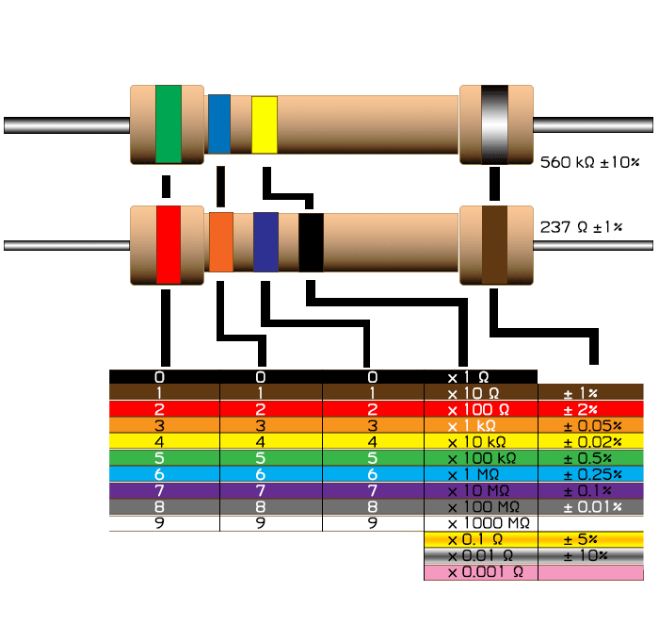
If your print is greyscale: the sequence of colors is black, brown, red, orange, yellow, green, blue, purple, grey and white.

More information on setting up a ssh connection can be found in https://www.raspberrypi.org/documentation/remote-access/ssh/
A good book for learning Python is: http://greenteapress.com/thinkpython/thinkpython.pdf . Also, the Beginners Guide mentioned before is a useful book to start with Python.
A pull-up resistor is connected between input or output and 3.3 V; in that way the port becomes 1 if nothing is connected to it (input) or no output value is specified. In a similar way a pull-down makes a floating port equal to 0.
A small tutorial on classes can be found in https://www.w3schools.com/python/python_classes.asp
Alternatively we can import os and ´pack´ the linux shell command in a python instruction: os.system('sudo pigpiod') at the start of using pigpio and os.system('sudo killall pigpiod') at the end.
Sintering is the process of compacting and making solids at low temperature – without melting.
Some types have 4 pins; top view (with raster): left = 5 V, second = data (with 5 k pull up resistor), pin 3 not connected and pin 4 to ground.
There are various models being used. Check the pin functions before connecting the converter to the RPi.
AIN0 – Jumper P5 – Light Dependent Resistor (LDR); AIN1 – Jumper P4 – Thermistor; AIN2 – Not connected; AIN3 – Jumper P6 – Potentiometer
A new process can be started by opening a new command shell.
A useful tutorial on image processing in as well images as video´s is found here: https://pythonprogramming.net/loading-video-python-opencv-tutorial/

